**Spanning Tree and Minimum Spanning Tree**

Before we learn about spanning trees, we need to understand two graphs: **undirected graphs and connected graphs.**

An **undirected graph** is a graph in which the **edges do not point in any direction** (ie. the edges are bidirectional).

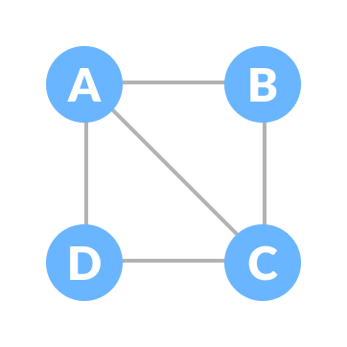

A **connected graph** is a graph in which **there is always a path from a vertex to any other vertex**.

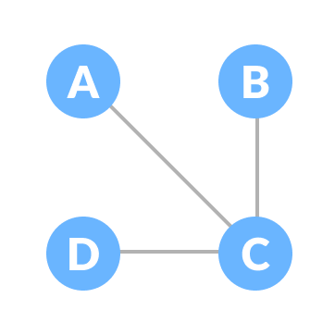

**Spanning Tree**

A spanning tree is a **sub-graph of an undirected connected graph**, which **includes all the vertices of the graph with a minimum possible number of edges**. If a vertex is missed, then it is not a spanning tree.

The total number of spanning trees with n vertices that can be created from a complete graph is equal to n(n-2)

If we have n = 4, the maximum number of possible spanning trees is equal to 44-2 = 16. Thus, 16 spanning trees can be formed from a complete graph with 4 vertices.

**Example of a Spanning Tree**

Let's understand the spanning tree with examples below:

Let the original graph be:

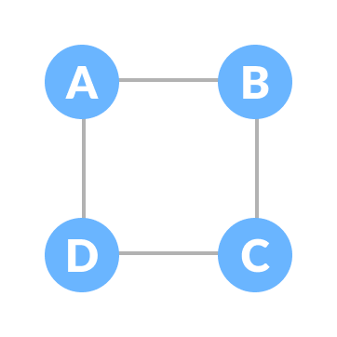

**Normal graph**

Some of the possible spanning trees that can be created from the above graph are:

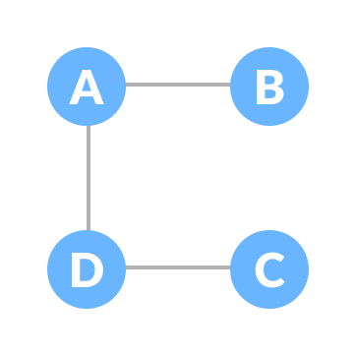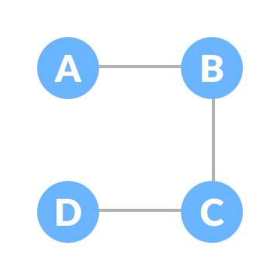

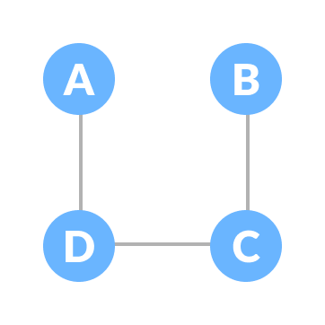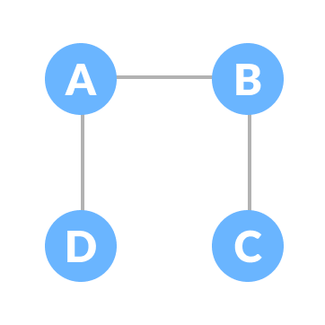

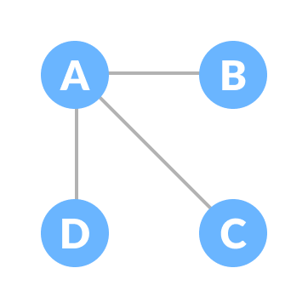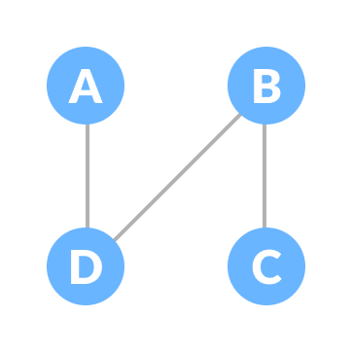

**Minimum Spanning Tree**

A minimum spanning tree is a spanning tree **in which the sum of the weight of the edges is as minimum as possible.**

**Example of a Spanning Tree**

Let's understand the above definition with the help of the example below.

The initial graph is:

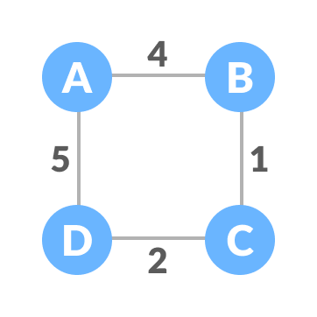

**Weighted graph**

The possible spanning trees from the above graph are:

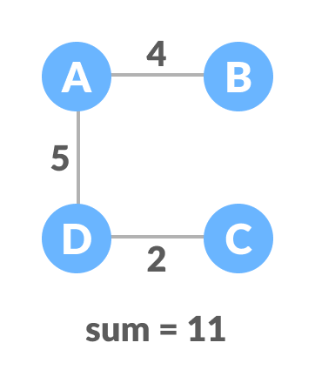Minimum spanning tree - 1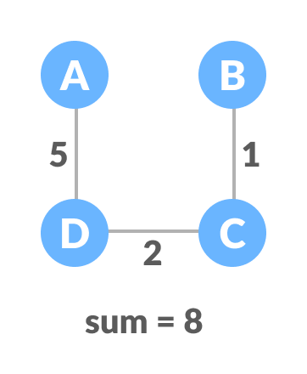Minimum spanning tree - 2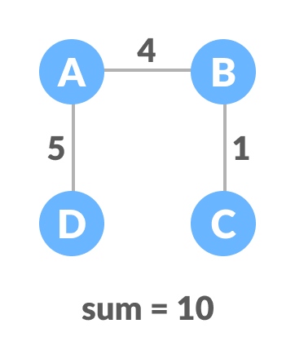Minimum spanning tree - 3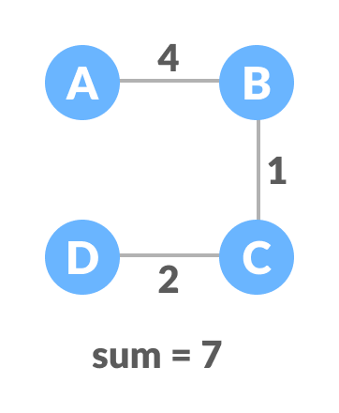Minimum spanning tree - 4

The minimum spanning tree from the above spanning trees is:



The minimum spanning tree from a graph is found using the following algorithms:

1. Prim's Algorithm
2. Kruskal's Algorithm

**Spanning Tree Applications**

* Computer Network Routing Protocol

**Minimum Spanning tree Applications**

* **To find paths in the map**